Program and Course 1 overview

Hello and welcome! This program has been specifically designed so every type of learner can be successful completing the seven courses for the Google Digital Marketing & E-commerce Career Certificate. These courses will help you prepare for an entry-level digital marketing coordinator or e-commerce specialist role. No prior experience in marketing or e-commerce is required.

**Become job-ready**

Why are skills in digital marketing and e-commerce in such high demand? One reason is that the world is undergoing a digital transformation. A growing number of people get their news and information online and through digital subscriptions instead of from television, radio, or printed publications. As a result, marketing professionals recognize that they must connect with potential customers using digital media. Similarly, for some businesses, revenue from online sales can equal or even exceed revenue from in-store purchases. Businesses must grow their online sales competitively and retain both types of customers.

During each course in the program, you will complete activities that include practice in tools that many marketing and e-commerce specialists use every day. In doing so, you’ll gain experience to effectively engage customers along each stage of their customer journey. By the end of this program, you’ll understand how to work on search engine optimization projects, digital marketing campaigns, e-commerce strategies, customer loyalty programs, and more.

**Course progress**

The entire program has seven courses. **Foundations of Digital Marketing and E-commerce** is the first course in the series.

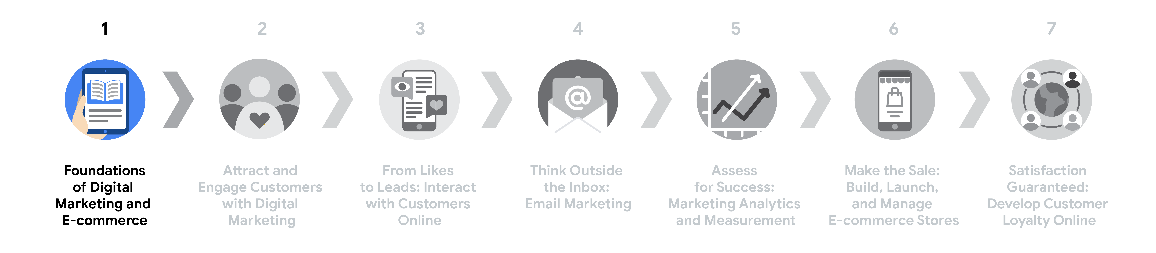

**Course flow**

1. [**Foundations of Digital Marketing and E-commerce**](https://www.coursera.org/learn/foundations-of-digital-marketing-and-e-commerce/home/week/1)—(*current course*) Learn about the fields of digital marketing and e-commerce and the skills needed for associate-level roles.
2. [**Attract and Engage Customers with Digital Marketing**](https://www.coursera.org/learn/digital-marketing-ecommerce-first-course-2/home/week/1)—Apply the marketing funnel concept to stages of the customer journey, including engagement, conversion, and loyalty. Learn methods for search engine optimization so potential customers find your products or services.
3. [**From Likes to Leads: Interact with Customers Online**](https://www.coursera.org/learn/digital-marketing-ecommerce-course-3/home/week/1)—Learn how to create marketing content and ads on social media platforms and evaluate their effectiveness using social media analytics data.
4. [**Think Outside the Inbox: Email Marketing**](https://www.coursera.org/learn/digital-marketing-ecommerce-course-4/home/week/1)—Learn how to execute email campaigns, use mailing lists, and automate customer communication and workflows.
5. [**Assess for Success: Marketing Analytics and Measurement**](https://www.coursera.org/learn/ec5/home/week/1)—Learn how to collect, monitor, analyze, and present data from marketing campaigns using analytics and presentation tools.
6. [**Make the Sale: Build, Launch, and Manage E-commerce Stores**](https://www.coursera.org/learn/ec6/home/week/1)—Learn the process to create a new e-commerce store and drive traffic to the online business through advertising campaigns.
7. [**Satisfaction Guaranteed: Develop Customer Loyalty Online**](https://www.coursera.org/learn/ec7/home/week/1)—Learn strategies to build customer loyalty in e-commerce and use specific tools to help develop and maintain client relationships. This course also closes out the program with professional development topics to help you prepare for a job search.

**What to expect**

Each course offers a series of lessons with many types of learning opportunities. These include:

* **Videos** for instructors to teach new concepts and demonstrate the use of tools
* **Readings** to introduce new ideas and build on the concepts from the videos
* [**Discussion forums**](https://www.coursera.org/learn/foundations-of-digital-marketing-and-e-commerce/discussions)to share, explore, and reinforce lesson topics for better understanding
* **Discussion prompts** to promote thinking and engagement in the discussion forums
* **Self reviews** to practice tasks and check your results for accuracy or correctness
* **In-video quizzes** to help your comprehension of content presented in videos
* **Practice quizzes** to prepare you for graded quizzes
* **Graded quizzes** to measure your progress, give you valuable feedback, and satisfy program completion to obtain a certificate—Following program guidelines, you can take a graded quiz multiple times to achieve a passing score of 80% or higher.

**Tips for success**

* It is strongly recommended to take these courses—and go through the items in each lesson—in the order they appear because new information and concepts build on previous knowledge.
* Participate in all learning opportunities to gain as much knowledge and experience as possible.
* If something is confusing, don’t hesitate to replay a video, review a reading, or repeat a self-review activity.
* Use the additional resources that are referenced throughout the program. They are designed to support your learning.
* When you encounter useful links in a course, remember to bookmark them so you can refer to the information later for study or review.
* Understand and follow the [**Coursera Code of Conduct**](https://www.coursera.support/s/article/208280036-Coursera-Code-of-Conduct?) to ensure that the learning community remains a welcoming, friendly, and supportive place for all members.

**Course 1 content**

This course has weekly assignments. You can complete them at your own pace; however, the weekly assignments are designed to help you finish the program in six months or fewer. Refer to the information below about weekly progression for this course. Congratulations on choosing to take this first step to build your skills for a career in digital marketing and e-commerce. Enjoy the journey!

**Week 1: Introduction to Foundations of digital marketing and e-commerce**

You’ll find out what’s in store for Course 1 and the whole certificate program. You’ll also learn about the Coursera platform, procedures, and content types, and meet other learners in the program. Then, you’ll learn about digital marketing and e-commerce basics, the tasks that people who work in these fields do, and the transferable skills you might already have. Finally, you’ll get some tips for embarking on careers in this field.

**Week 2: The customer journey and the marketing funnel**

You will learn what digital marketing and e-commerce roles and departments do within organizations and how they create value. You’ll also be introduced to marketing concepts, like the customer journey and the marketing funnel, that form the basis for much of what these roles do.

**Week 3: Digital marketing and e-commerce strategy**

You will explore the relationship between digital marketing and branding, and how businesses can leverage both to be successful. You’ll investigate the elements of a digital marketing strategy, including goal setting, channel selection, and content planning. Then you’ll learn about commonly used channels and platforms, like search engine optimization (SEO), search engine marketing (SEM), display advertising, social media marketing, and email marketing.

**Week 4: Measure performance success**

You will learn the importance of measuring results and common metrics to track. You’ll also examine how digital marketers and e-commerce specialists use data to assess and improve performance and tell stories with data. You’ll end the course by participating in optional content if you’re interested in preparing for a job search.

Mark as completed

Like

Dislike

Report an issue

TASK 2

# Helpful resources to get started

As a learner, you can complete this course only. However, to obtain a certificate, you must complete all the courses in the program. This reading describes what is required to obtain a certificate and best practices for you to have a good learning experience on the platform.

## Course completion to obtain a certificate

To submit graded assignments and be eligible to receive a Google Digital Marketing and E-commerce Career Certificate, you must do the following:

* Pay the [course certificate fee](https://www.coursera.support/s/article/209818963-Payments-on-Coursera?language=en_US), or apply and be approved for a [Coursera Financial Aid](https://www.coursera.support/s/article/209819033-Apply-for-Financial-Aid-or-a-Scholarship?language=en_US).
* Pass all graded assignments in the seven courses at the minimum passing level, or above. Each graded assignment in a course is part of a cumulative grade for that course. The passing score for each course is 80%.

## Healthy habits for course completion

Here is a list of best practices that will help you complete the courses in the program in a timely manner:

* **Plan your time:** Setting regular study times and sticking with them each week can help you make learning a part of your routine. Use a calendar or timetable to create a schedule, and list what you plan to do each day in order to break your work down into achievable goals. Create a quiet place to watch the videos, review the readings, and complete the activities so you can really focus on the material.
* **Work at your own pace:** Everyone learns differently, so this program has been designed to let you work at your own pace. Although your personalized deadlines start when you enroll, they are just a guide. Feel free to move through the program at the speed that works best for you. There is no penalty for late assignments; to earn your certificate, all you have to do is complete all of the work. If you prefer, you can extend your deadlines by returning to **Overview** in the navigation panel to click **Switch Sessions**. If you already missed previous deadlines, click **Reset my deadlines** instead.
* **Be curious:** If you find an idea that gets you excited, act on it! Ask questions, search for more details online, check out the links that interest you, and take notes on your discoveries. The little things you do to support your learning along the way will take your knowledge even further, open more doors in this high-growth field, and help you qualify for jobs.
* **Take notes:** Notes are useful-to-remember information that you think might be important in the future, especially as you’re preparing to enter a new job field. In addition, taking notes is an effective way to make connections between topics and gain a better understanding of those topics.
* **Chat (responsibly) with other learners:** If you have a question, chances are, you’re not alone. Reach out in the discussion forum to ask for help from other learners in this program. You can also visit Coursera’s [Global Online Community](https://coursera.community/). Other important things to know while learning with virtual classmates can be found in the [Coursera Honor Code](https://learner.coursera.help/hc/en-us/articles/209818863-Coursera-Honor-Code) and [Code of Conduct](https://learner.coursera.help/hc/en-us/articles/208280036-Coursera-Code-of-Conduct).
* **Update your profile:** Consider [updating your profile](https://www.coursera.org/account/profile) on Coursera. This link appears in the menu when you click on your name at the top-right corner of this screen. When classmates find you in the discussion forums, they can click on your name to view your profile and get to know you more.

## Documents, spreadsheets, and presentations for course activities

To complete certain activities in the program, you will need to use digital documents, spreadsheets, or presentations. Marketing professionals use these software tools to collaborate within their teams and organizations. If you need more information about using a particular tool, refer to these resources:

* [Microsoft Word: Help and learning](https://support.microsoft.com/en-us/word): Microsoft Support page for Word
* [Google Docs](https://support.google.com/docs/topic/9046002?hl=en&ref_topic=1382883): Help Center page for Google Docs
* [Microsoft Excel: Help and learning](https://support.microsoft.com/en-us/excel): Microsoft Support page for Excel
* [Google Sheets](https://support.google.com/docs/topic/9054603?hl=en&ref_topic=1382883): Help Center page for Google Sheets
* [Microsoft PowerPoint: Help and learning](https://support.microsoft.com/en-us/powerpoint): Microsoft Support page for PowerPoint
* [How to use Google Slides](https://support.google.com/docs/answer/2763168?hl=en&co=GENIE.Platform%3DDesktop): Help Center page for Google Slides

## Course glossary

This course will cover a lot of terms and concepts, some of which you may already know and some of which will be new. To remind yourself about what a term means, or to help you review concepts for graded quizzes, refer to the [Glossary](https://www.coursera.org/learn/foundations-of-digital-marketing-and-e-commerce/resources/OXidW) for this course.

## Course feedback

Providing feedback on videos, readings, and other materials is easy. With the resource open in your browser, look for the thumbs-up and thumbs-down symbols.

* Click thumbs-up for materials that are helpful.
* Click thumbs-down for materials that are not helpful.

If you want to flag a specific issue with an item, click the flag icon, select a category, and enter an explanation in the text box. This feedback goes back to the course development team and isn’t visible to other learners. All feedback received helps to create even better certificate programs in the future.

For technical help on the platform, visit the [Learner Help Center](https://learner.coursera.help/hc/en-us).

# Helpful resources to get started

As a learner, you can complete this course only. However, to obtain a certificate, you must complete all the courses in the program. This reading describes what is required to obtain a certificate and best practices for you to have a good learning experience on the platform.

## Course completion to obtain a certificate

To submit graded assignments and be eligible to receive a Google Digital Marketing and E-commerce Career Certificate, you must do the following:

* Pay the [course certificate fee](https://www.coursera.support/s/article/209818963-Payments-on-Coursera?language=en_US), or apply and be approved for a [Coursera Financial Aid](https://www.coursera.support/s/article/209819033-Apply-for-Financial-Aid-or-a-Scholarship?language=en_US).
* Pass all graded assignments in the seven courses at the minimum passing level, or above. Each graded assignment in a course is part of a cumulative grade for that course. The passing score for each course is 80%.

## Healthy habits for course completion

Here is a list of best practices that will help you complete the courses in the program in a timely manner:

* **Plan your time:** Setting regular study times and sticking with them each week can help you make learning a part of your routine. Use a calendar or timetable to create a schedule, and list what you plan to do each day in order to break your work down into achievable goals. Create a quiet place to watch the videos, review the readings, and complete the activities so you can really focus on the material.
* **Work at your own pace:** Everyone learns differently, so this program has been designed to let you work at your own pace. Although your personalized deadlines start when you enroll, they are just a guide. Feel free to move through the program at the speed that works best for you. There is no penalty for late assignments; to earn your certificate, all you have to do is complete all of the work. If you prefer, you can extend your deadlines by returning to **Overview** in the navigation panel to click **Switch Sessions**. If you already missed previous deadlines, click **Reset my deadlines** instead.
* **Be curious:** If you find an idea that gets you excited, act on it! Ask questions, search for more details online, check out the links that interest you, and take notes on your discoveries. The little things you do to support your learning along the way will take your knowledge even further, open more doors in this high-growth field, and help you qualify for jobs.
* **Take notes:** Notes are useful-to-remember information that you think might be important in the future, especially as you’re preparing to enter a new job field. In addition, taking notes is an effective way to make connections between topics and gain a better understanding of those topics.
* **Chat (responsibly) with other learners:** If you have a question, chances are, you’re not alone. Reach out in the discussion forum to ask for help from other learners in this program. You can also visit Coursera’s [Global Online Community](https://coursera.community/). Other important things to know while learning with virtual classmates can be found in the [Coursera Honor Code](https://learner.coursera.help/hc/en-us/articles/209818863-Coursera-Honor-Code) and [Code of Conduct](https://learner.coursera.help/hc/en-us/articles/208280036-Coursera-Code-of-Conduct).
* **Update your profile:** Consider [updating your profile](https://www.coursera.org/account/profile) on Coursera. This link appears in the menu when you click on your name at the top-right corner of this screen. When classmates find you in the discussion forums, they can click on your name to view your profile and get to know you more.

## Documents, spreadsheets, and presentations for course activities

To complete certain activities in the program, you will need to use digital documents, spreadsheets, or presentations. Marketing professionals use these software tools to collaborate within their teams and organizations. If you need more information about using a particular tool, refer to these resources:

* [Microsoft Word: Help and learning](https://support.microsoft.com/en-us/word): Microsoft Support page for Word
* [Google Docs](https://support.google.com/docs/topic/9046002?hl=en&ref_topic=1382883): Help Center page for Google Docs
* [Microsoft Excel: Help and learning](https://support.microsoft.com/en-us/excel): Microsoft Support page for Excel
* [Google Sheets](https://support.google.com/docs/topic/9054603?hl=en&ref_topic=1382883): Help Center page for Google Sheets
* [Microsoft PowerPoint: Help and learning](https://support.microsoft.com/en-us/powerpoint): Microsoft Support page for PowerPoint
* [How to use Google Slides](https://support.google.com/docs/answer/2763168?hl=en&co=GENIE.Platform%3DDesktop): Help Center page for Google Slides

## Course glossary

This course will cover a lot of terms and concepts, some of which you may already know and some of which will be new. To remind yourself about what a term means, or to help you review concepts for graded quizzes, refer to the [Glossary](https://www.coursera.org/learn/foundations-of-digital-marketing-and-e-commerce/resources/OXidW) for this course.

## Course feedback

Providing feedback on videos, readings, and other materials is easy. With the resource open in your browser, look for the thumbs-up and thumbs-down symbols.

* Click thumbs-up for materials that are helpful.
* Click thumbs-down for materials that are not helpful.

If you want to flag a specific issue with an item, click the flag icon, select a category, and enter an explanation in the text box. This feedback goes back to the course development team and isn’t visible to other learners. All feedback received helps to create even better certificate programs in the future.

For technical help on the platform, visit the [Learner Help Center](https://learner.coursera.help/hc/en-us).

Mark as completed

Like

Dislike

Report an issue

Roles and responsibilities in digital marketing and e-commerce

In another reading, you were introduced to examples of job responsibilities in digital marketing coordinator and e-commerce analyst roles. This reading summarizes other associate or entry-level roles and responsibilities in digital marketing and e-commerce. At the end of the reading, you’ll find advice on how you can potentially progress from a starting role to roles with further growth opportunities.

**Associate-level roles in digital marketing**

Below are some examples of responsibilities for associate-level roles in digital marketing. These lists aren't comprehensive but are intended to showcase a variety of responsibilities in each role.

* **Digital marketing coordinator\***
  + Coordinate marketing activities and initiatives
  + Identify target audiences through research
  + Run campaigns
  + Monitor metrics to evaluate trends

***\**** *Also described in another video and reading*

* **Marketing associate**
  + Prepare reports on marketing and sales metrics
  + Collect and analyze customer behavior metrics, such as web traffic and search rankings
  + Coordinate with marketing teams to generate digital advertising materials
  + Assist with ongoing marketing campaigns
* **Search Engine Optimization (SEO) specialist**
  + Develop optimization strategies to improve search rankings
  + Implement keywords for SEO
  + Monitor metrics to understand SEO performance
  + Update links for optimization of search rankings
* **Search Engine Marketing (SEM) specialist**
  + Identify customer personas to enable marketing to identified audiences
  + Perform research on keywords for SEO and Pay Per Click (PPC) ads
  + Monitor metrics to optimize paid search performance
  + Identify and monitor key performance indicators (KPIs) for SEM
* **Social media specialist**
  + Develop, implement, and manage a social media marketing strategy
  + Collaborate with sales and marketing teams on social media campaigns
  + Create content to build customer connections and increase brand awareness
  + Monitor metrics in social media campaigns for customer engagement and content optimization insights
* **Email marketing specialist**
  + Create email marketing campaigns to promote products or services
  + Create an archive of emails for lead generation
  + Purge non-deliverable and unsubscribed email addresses
  + Use metrics to monitor the performance of email campaigns

**Associate-level roles in e-commerce**

Below are some examples of responsibilities for associate-level roles in e-commerce. These lists aren't comprehensive but are intended to showcase a variety of responsibilities in each role.

* **E-commerce analyst\***
  + Implement e-commerce strategies to support business goals
  + Set e-commerce goals and key performance indicators (KPIs) for key attributes like audience, acquisition, behavior, and conversions
  + Monitor and analyze e-commerce metrics
  + Leverage e-commerce data for operational insights

***\**** *Also described in another reading*

* **E-commerce specialist**
  + Develop and run campaigns to increase digital sales as part of an overall digital marketing strategy
  + Optimize paid advertising campaigns using SEO and other tools
  + Manage an online marketing presence, including social media platforms
  + Monitor metrics for spikes in website traffic or sales

**Advance to roles that further your growth**

Starting an entry-level role in marketing or e-commerce is exciting, but after you gain practical experience and hands-on work using tools in that role, you might be eager to advance your career.

If you’re ready for a new role, below are a few possibilities and a sampling of responsibilities for each.

* **Digital marketing manager**
  + Plan and execute digital marketing, including SEO/SEM, email, social media, and display advertising campaigns
  + Measure and report performance and return on investment (ROI) for digital marketing
  + Plan, execute, and evaluate A/B tests and experiments
  + Evaluate and improve the end-to-end customer experience across multiple channels and customer touchpoints
* **Social media strategist**
  + Manage and oversee social media content
  + Measure the success of social media campaigns
  + Monitor and analyze metrics to recommend effective content optimization solutions
  + Network with industry professionals and influencers using social media
* **Account manager**
  + Build and maintain client relationships
  + Ensure the timely and successful delivery of advertising solutions based on customer needs and objectives
  + Clearly communicate the progress of initiatives to internal and external stakeholders
  + Forecast and monitor key account metrics
* **E-commerce product manager**
  + Conduct market research
  + Develop a product strategy for an e-commerce business based on analytics
  + Define website and mobile app functionality, and deliver an optimal user experience for both
  + Understand business objectives and coordinate efforts to increase sales

**Key takeaways**

Career progression is very individualized. Sometimes it can take less than a year to be ready to advance to the next level; often it can take a few years. Here are three signs that you could be ready to progress to the next level.

1. You consistently meet or exceed job-related performance goals.
2. You’re assigned tasks associated with a higher-level role.
3. You recently asked for more work while performing your job.

Keep in mind that your career can advance at a speed that is right for you. Always be ready and open to new opportunities by demonstrating a positive attitude and a growth mindset in whatever role you’re in!

Mark as completed

Like

Dislike

Report an issue

E-commerce, ecommerce, or eCommerce?

Which is the correct term: e-commerce, ecommerce, eCommerce, or just ecomm for short? The name and spelling of **e-commerce** has evolved over the last 30 years, and so have the technologies and job skills required to work in this field. This reading provides a summary of e-commerce's evolution by describing the history of the term and by laying out the four distinct models within e-commerce that have emerged over the years.

Like most everything on the internet, e-commerce — although it hasn't been around that long — has evolved and changed a lot. What started as electronic commerce, quickly progressed into e-commerce, ecommerce, or eCommerce. But how can you know which one to use? In this course, you'll see e-commerce used. That's, in part, because Google Trends — a website that analyzes popularity of top search queries in Google Search — shows most people prefer using **e-commerce**, as opposed to **ecommerce** or **eCommerce**. Since the word is a combination of two words, the use of the hyphen makes that more clear. Now, let's talk about the four distinct models within e-commerce:

* Business-to-consumer (B2C)
* Consumer-to-consumer (C2C)
* Business-to-business (B2B)
* Consumer-to-business (C2B)

**Note:** When a government entity does business online, substituting *business* with *administration* results in additional e-commerce models like business-to-administration (B2A) and consumer-to-administration (C2A).

**Business-to-consumer (B2C) e-commerce**

Business-to-consumer (B2C) is the most common form of e-commerce. This is the online process of businesses selling products or services directly to consumers. Some credit the U.S. company Pizza Hut for the first e-commerce transaction (selling a pizza online). However, historians also recognize that before that pizza sale, Dan Kohn sold a CD album to a friend in Philadelphia on August 11, 1994. That friend sent his credit card information to pay for the album and shipping costs using encryption technology. Others couldn’t steal his credit card information because it was encrypted!

Today, B2C e-commerce generates billions of dollars in revenue annually, with encrypted transactions as everyday occurrences. With B2C marketing, you have opportunities to apply your digital marketing skills in very specific ways. For example, you can become a specialist in experiential marketing or social media marketing, or even a subset of social media marketing called influencer marketing.

* **Experiential marketing**, also known as engagement marketing, encourages consumers to not only purchase a brand or product but to *experience* it. Experiential marketing campaigns draw out emotional responses from their audiences.
* **Social media marketing** creates content for different social media platforms to drive engagement and promote a business or product.
* **Influencer marketing** enlists influential people to endorse or mention a brand or product to their followers on social media.

**Consumer-to-consumer (C2C) e-commerce**

With consumer-to-consumer (C2C) e-commerce, individuals sell products or services to other individuals. In other words, consumers buy items from each other. Boston Computer Exchange created the first platform for C2C e-commerce in 1982. An online community of people used this platform to sell their used computers to other users. However, the best-known early C2C e-commerce platform is eBay, founded in 1995.

Today, C2C e-commerce still occurs on platforms like eBay and Etsy. Business-to-consumer platforms like Amazon also host C2C sales. Social media platforms like Facebook also entered C2C e-commerce with Facebook Marketplace. Digital marketing for a C2C business prioritizes skills in search engine optimization (SEO), content creation, and social media since most C2C consumers find each other through blogs and social media posts. Their shared interests lead to C2C transactions to buy and sell items.

**Business-to-business (B2B) e-commerce**

Business-to-business (B2B) e-commerce enables businesses to sell products and services to other businesses. The rise of services, particularly software services, accelerated B2B e-commerce. This type of service is known as Software-as-a-Service (SaaS). One example of a SaaS company is Salesforce, founded in 1999. SaaS companies, like Salesforce, provide other companies subscription access to business-critical services over the internet. For example, Salesforce provides customer relationship management (CRM) software that unifies sales, marketing, and services for a personalized customer journey.

Today, digital marketers for B2B companies use many of the same skills as digital marketers for B2C companies. However, B2B marketing campaigns require more precise identification of their target audiences. Selling to businesses requires a focus on communicating an immediate value to potential customers. Therefore, digital marketing for B2B companies tends to be more strategic. There may be fewer opportunities to specialize in one type of marketing, like social media marketing, and a greater emphasis on marketing analytics and data.

**Consumer-to-business (C2B) e-commerce**

The popularity of small business ownership helped establish another model for e-commerce, C2B. With C2B e-commerce, consumers sell their products or services to businesses. Specialized platforms also fill a need for these online transactions. For example, Upwork, founded in 2015, connects freelancers to businesses that may need their skills and services.

Consumers who are influencers may also fall into this category of e-commerce because they may sell their services to promote a company’s products. With social media continuing to expand its influence on consumer decisions, the C2B e-commerce model will likely grow as well.

**Key takeaway**

This exploration of e-commerce models demonstrates that e-commerce has evolved and will continue to change rapidly. Knowing how to apply and gain new digital marketing skills is vital in advancing your career in this industry.

Mark as completed

Like

Dislike

Report an issue

Advantages and challenges of digital marketing

Traditional marketing is marketing that isn't online. Marketers reach potential customers through printed media, television, radio, direct mail, phone calls, or billboards. Digital marketing is marketing that is exclusively online. Digital marketers focus on potential customers who engage with online content, including search engine results, email, video, blogs, or social media.

This reading describes the advantages digital marketing has over traditional marketing and some definite challenges, too.

**Digital marketing advantages**

Digital marketing has certain advantages over traditional marketing because it:

* Reduces wasteful spending
* Adapts to new technologies
* Reaches target audiences with more precision

**Spending**

Digital marketing uses content in a variety of formats that can be easily converted from one format to another, making spending more cost-effective. Digital marketing also reduces wasteful spending. For example, television or billboard ads are equally seen by those who have an interest in your company or product and those who don’t. Traditional marketing always wastes some budget on people who will never buy a product or service. In contrast, digital ads can be selectively shown to people who are more likely to have an interest in that product or service. Digital marketing that is more strategically focused on the right people yields a better return on spending.

**Technology**

Various technologies enable organizations to engage and interact with customers more effectively, which is a big part of digital marketing. Developing a good online relationship with customers makes them more likely to find your business, become loyal customers, and even share their recommendations with others.

Digital marketing tools also enable companies to collect data and measure the results of their marketing efforts more effectively. When marketers receive data faster, they’re able to change direction easily if a marketing effort isn’t producing the results expected. Measuring the success of digital marketing campaigns is key to ensuring that you get the results you want.

Digital marketing adapts to new technologies. There are always new opportunities to reach customers in different ways, especially compared to traditional marketing.

**Target audiences**

Digital marketing tools and data enable you to expand your customer reach well beyond that of traditional marketing. Ad visibility and audience coverage can be tailored to meet your specific business needs and goals. When you reach the right audiences, you’re more likely to increase sales and develop sustainable customer loyalty programs.

**Digital marketing challenges**

Digital marketing also has certain challenges that are associated with spending, technology, and target audiences. For each advantage previously identified, there are also associated challenges.

**Spending**

**Advantage:** Digital content is easier to create.

**Challenge:** Organizations engage in **omnichannel marketing**—the integration or synchronization of content on multiple channels—so customers can have a consistent brand experience. This increases the amount of content required, so even if it’s easier to create digital content, much more content needs to be created overall. Furthermore, it’s not just about the amount of content created, but its quality. Advertising is a crowded space. Content must be distinctive to positively impact customer awareness and change their behavior.

**Advantage:** Digital marketing is more cost-effective than traditional marketing.

**Challenge:** If an organization is working towards an omnichannel presence, the cost for marketing on all channels adds up quickly. Getting support or buy-in for extra or additional budget to cover the cost can be difficult.

**Technology**

**Advantage:** Digital marketing adapts to new technologies.

**Challenge:** As a marketer, learning and keeping up with new technologies and tools is a constant requirement. Marketers must also stay up-to-date with and follow all user privacy and data sharing regulations worldwide. Omnichannel marketing also makes it more difficult to track where sales come from. Marketers must rely more heavily on analytics tools to help them do that.

**Target audiences**

**Advantage:** Digital marketing tools expand customer reach using specific audiences.

**Challenge:** The digital space is a crowded field that’s getting even more crowded. It’s harder for marketers to stand out with their advertising, even when they are targeting the right audiences.

**Key takeaways**

Various technologies make digital marketing more cost-effective and adaptable than traditional marketing. Digital marketing tools also enable more advanced and targeted audience selection for marketing campaigns. However, these benefits come with some challenges. In a digital space that’s both crowded and noisy, it’s harder for a company’s brand and advertising to stand out. Marketing professionals must keep up with technological advances and customer behaviors that change rapidly.

Mark as completed

Like

Dislike

Report an issue

# Inclusive marketing

As a digital marketer, being inclusive is an essential part of making deeper connections with your customers. **Inclusive marketing** is the practice of improving representation and belonging within the marketing and advertising materials that an organization creates.

In this reading, you’ll discover why inclusive marketing is important and how a company can make inclusion part of their marketing and advertising strategies.

## Why inclusive marketing matters

In digital marketing, the creative choices a company makes can impact how people view themselves and how they view other people. Sometimes marketing campaigns (especially those that are older or more traditional) can reinforce stereotypes and leave out the perspectives of underrepresented groups of people. Inclusive marketing, on the other hand, seeks to represent a variety of perspectives, particularly those that have been marginalized in the past.

If a company focuses its marketing exclusively on a specific age group, gender, ethnicity, or other identity traits, they’re likely missing out on reaching potential customers. By approaching marketing decisions with a focus on inclusion, a company can positively and authentically market to the diversity that exists in their audience, and the world.

## Making inclusive choices and avoiding stereotypes

Digital marketing requires getting to know your audience in a deeper way. With inclusive marketing, you can take this a step further by seeking to understand how parts of your target audience have been excluded, stereotyped, or misrepresented in the past.

Sometimes you might unintentionally overlook certain aspects of diversity, even if you remember to consider others. Here is a list of some identity traits that are helpful to keep in mind when you’re creating marketing or advertising materials for the people you’re trying to reach:

* Race
* Socioeconomic status
* Age
* Ability
* Gender
* Sexual orientation
* Religion
* Geographic location
* Culture
* Political perspective
* Military status
* Languages spoken

Gathering information about your audience’s demographics can help you broaden your perspective. It’s also important to consider the demographics of people who are not currently customers. These people may not use or even know about the products or services your company provides because the company’s marketing efforts haven’t reached them. By understanding their needs and desires, you can find a way to reach this group of people in a way that matters to them.

As an example, at least one billion people in the world live with a disability. If your product or service isn’t accessible to these people, they likely don’t use or even know about your product or service. And if your company’s marketing efforts don’t feature people with disabilities or address their needs, they may not view your company’s products or services as relevant to them.

That’s why it’s important to think deeply about your audience and their needs and to make sure their perspectives and stories are brought to life through the company’s marketing and advertising materials.

## Key takeaways

Whether you’re developing marketing goals, researching your target audience, planning a marketing campaign, or analyzing data, keep in mind the principles of inclusive marketing. Maintaining a broader perspective of your audience will help you establish a deeper connection with your customers.

## Resources for more information

You can learn more by reading the inclusive marketing guidelines and principles provided by Google.

* [Google Inclusive Marketing](https://all-in.withgoogle.com/): Find tools and resources for inclusive marketing.

Mark as completed

Like

Dislike

Report an issue

# What is a touchpoint?

You learned that before a purchase happens, each interaction with a brand during a customer journey is called a **touchpoint**.

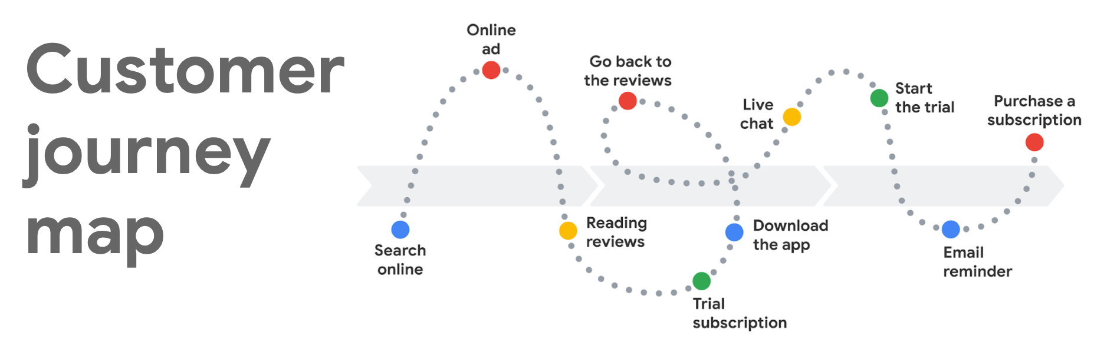Customer journey map with touchpoints, including search, reading reviews, live chat, trial subscription, email reminder, and purchase.

Touchpoints are important to monitor because they reveal the kinds of decisions customers are making during their customer journey to purchase your product or service. Touchpoints occur when a customer engages with your website or mobile app. But they also include customer interactions on all media channels before a customer discovers your website.

This reading explains how to classify touchpoints for media channels, and how to use these touchpoints to learn more about your customers.

## Touchpoints relate to a specific context or need

When you identify touchpoints, you may be tempted to list social media or display ads. These channels may be the mediums in which touchpoints occur, but actual touchpoints provide much more information. When you identify a touchpoint, think about how the interaction might satisfy a customer need.

For example, instead of classifying social media as a touchpoint, classify a customer’s response to a flash sale announcement on Twitter as a touchpoint. When they click the link, they are interested in knowing what they can purchase at a discounted price.

From the example, notice how much contextual information is lost if you simply lump every social media interaction under a single touchpoint called social media.

Touchpoints have context and reflect customer needs. In the example, the context was curiosity, and the need was saving money.

## Touchpoints are customer-centric

Touchpoints should also be customer-centric. Going back to the previous example, imagine if you viewed touchpoints from the perspective of the business instead of from the customer experience. If increasing sales is a business goal, touchpoints can easily become part of a rolling calculation, like a ratio of touchpoints to purchases.

While a ratio of touchpoints to purchases is still informative, notice how a customer-centric versus a business-centric analysis can provide more insights about buyer motivations.

## Key takeaways

Use touchpoints to your advantage. To get the most from touchpoints, carefully define them for all media channels. Touchpoints that are customer-centric and relate back to their needs will yield the most useful data about customer motivations, preferences, and behaviors.

Mark as completed

Like

Dislike

Report an issue

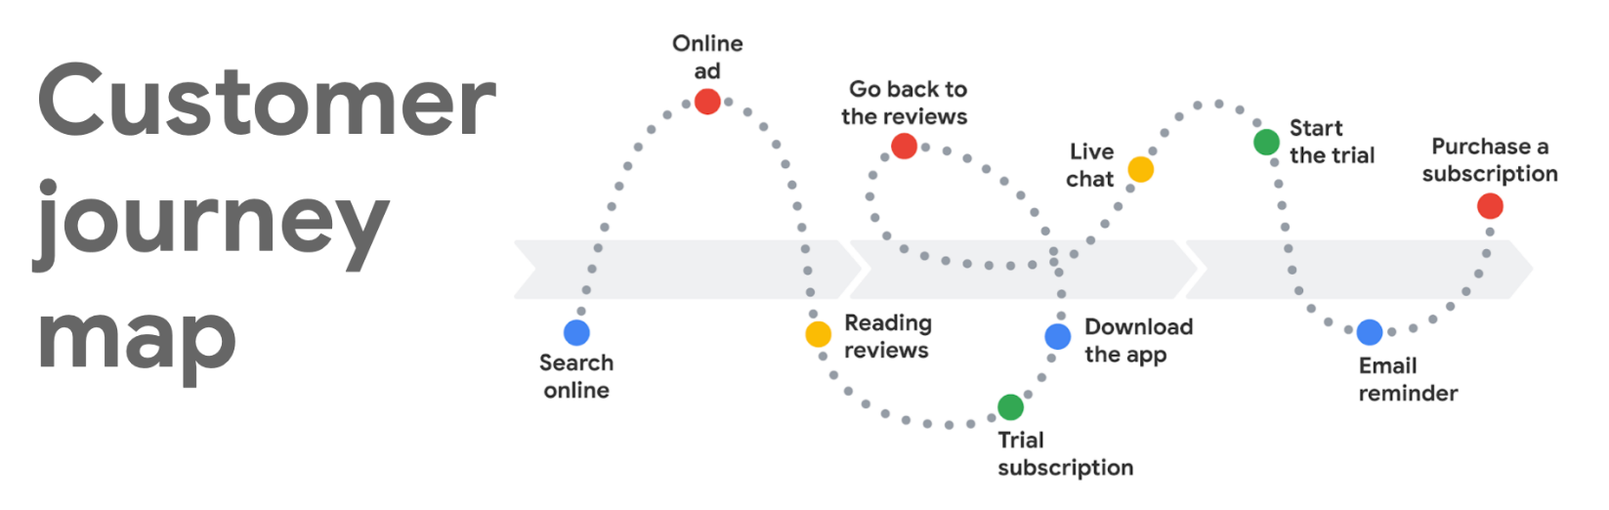

The traditional marketing funnel to the digital marketing funnel

A marketing funnel is a powerful way for businesses to focus and coordinate their marketing efforts. To get the most out of a marketing funnel, businesses must optimize their work at each stage of the funnel to reach desired outcomes.

The marketing funnel video in this course introduced you to a simple and generalized funnel design with four stages:

* Awareness
* Consideration
* Conversion
* Loyalty

You also learned that there are multiple versions of marketing funnels. Marketing funnels have been revised over time to reflect changes in business, technology, and even customer behavior. This reading provides a brief history of the funnel’s evolution.

**Evolution of the marketing funnel**

How is tofu related to a marketing funnel? Actually, **ToFU** (not the bean curd product) is an acronym for Top of Funnel. There’s also **MoFU** and **BoFU** which stand for Middle of Funnel and Bottom of Funnel, respectively. When using any funnel, the aim is to get the most desirable outcomes for ToFU, MoFU, and BoFU. As you read about different funnel designs, you can also think about how the desired ToFU, MoFU, and BoFU outcomes for each are similar or different.

**Traditional sales funnel**

Funnels probably took shape first as sales funnels. A simple sales funnel has awareness, interest, decision, and action stages as depicted in the following graphic.

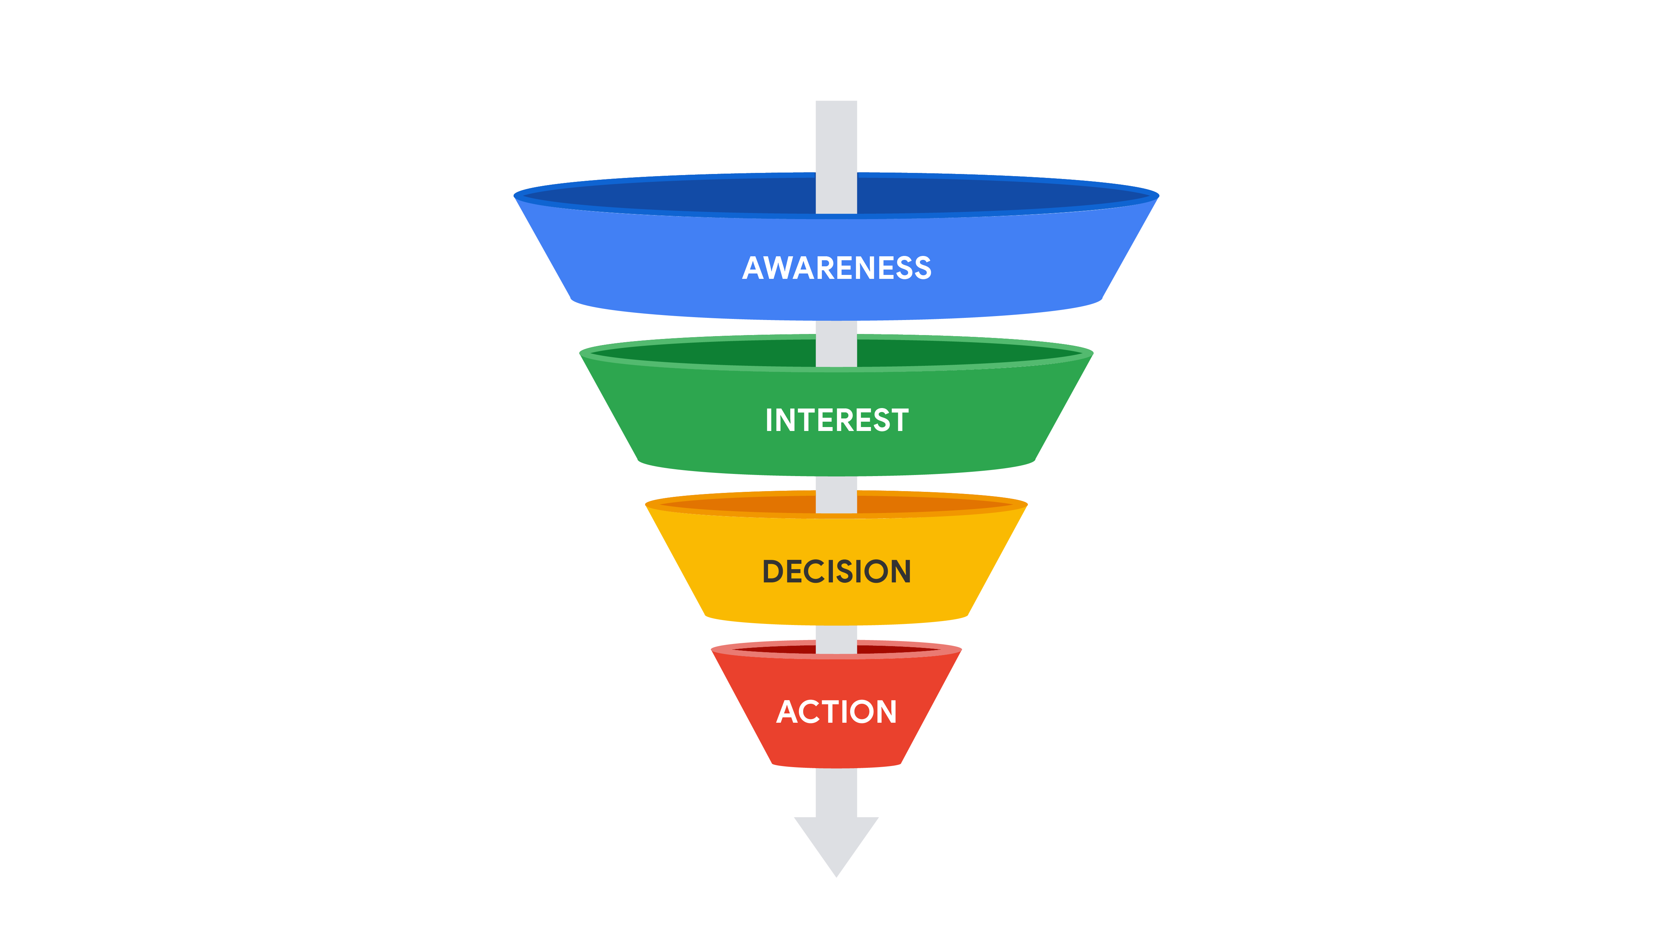

Desirable outcomes for a sales funnel, like the one shown in the graphic, might be:

* **Awareness (ToFU):** The customer has a general awareness of your brand, product, or service.
* **Interest (MoFU):** Your brand, product, or service comes up as a top choice when the customer researches, comparison shops, or thinks about options.
* **Decision (MoFU):** The customer chooses your brand, product, or service over your competitor’s.
* **Action (BoFU):** The customer purchases your brand, product, or service.

**Combined marketing and sales funnel**

Most likely, combined funnels for marketing and sales grew out of sales funnels. One example is shown below.

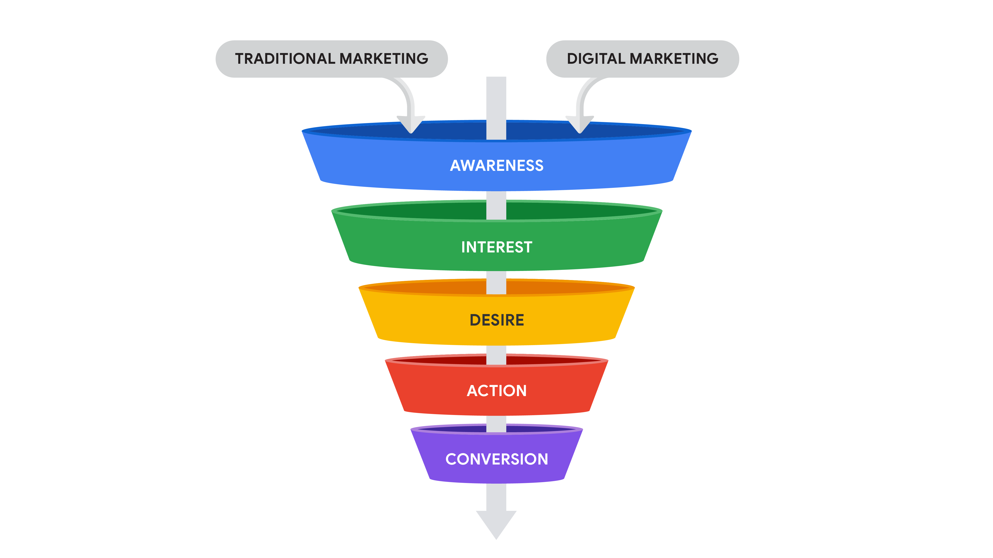Funnel with Traditional and Digital Marketing inputs at the top of the funnel and Awareness, Interest, Desire, Action, and Conversion as downward-progressing stages of the funnel.

Desirable outcomes for a combined sales and marketing funnel, like the one shown in the graphic, might be:

* **Awareness (ToFU):** The customer has a general awareness of your brand, product, or service.
* **Interest (MoFU):** Your brand, product, or service comes up as a top choice when the customer researches, comparison shops, or thinks about options.
* **Desire (MoFU):** The customer has motivation or an incentive to purchase your brand, product, or service.
* **Action (BoFU):** The customer purchases your brand, product, or service for the first time.
* **Conversion (BoFU):** The customer makes regular purchases and a customer relationship is established.

**Digital marketing funnel**

As business and technology evolved, more specialized funnels were then developed, as in the case of a funnel entirely dedicated to *digital* marketing. An example of a specialized digital marketing funnel is shown below. Note that the Remarketing stage of the funnel is only for customers who engaged with your brand, product, or service at least once before and didn’t previously convert. New customers can proceed directly from the Consideration stage to the Conversion stage.

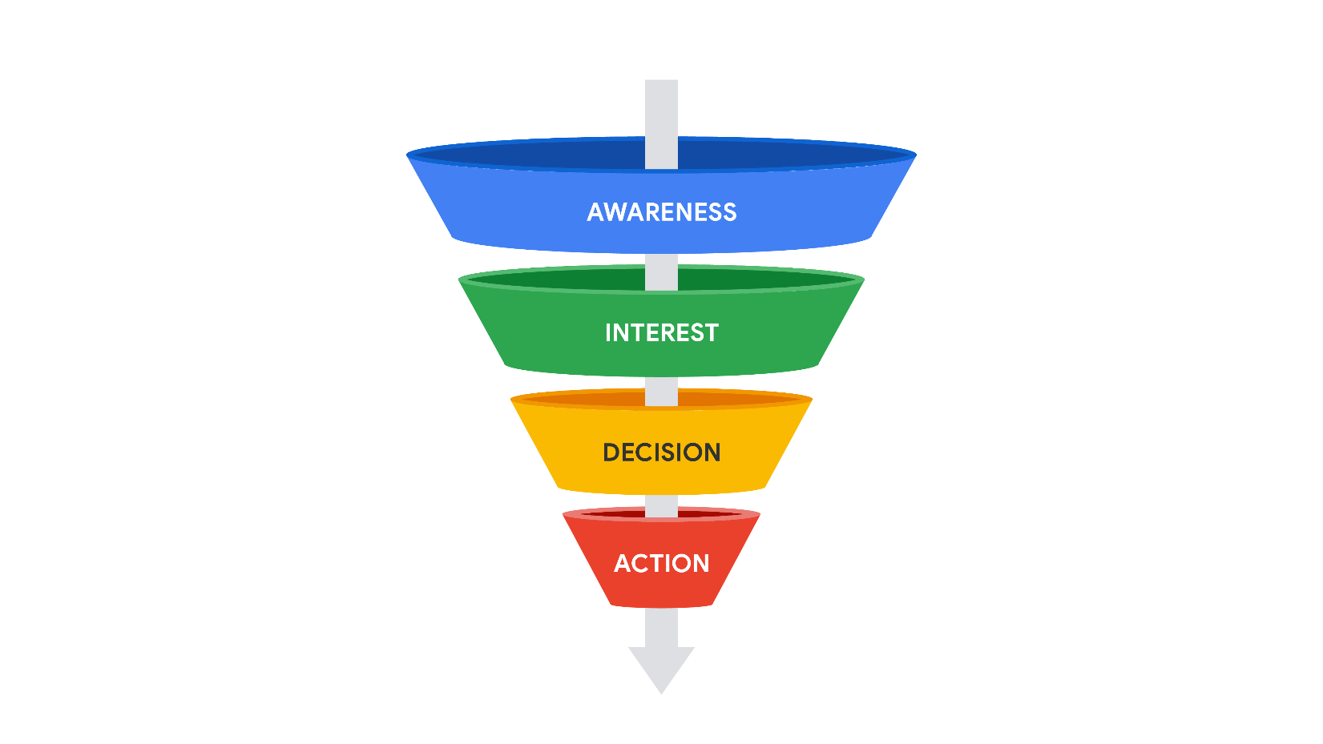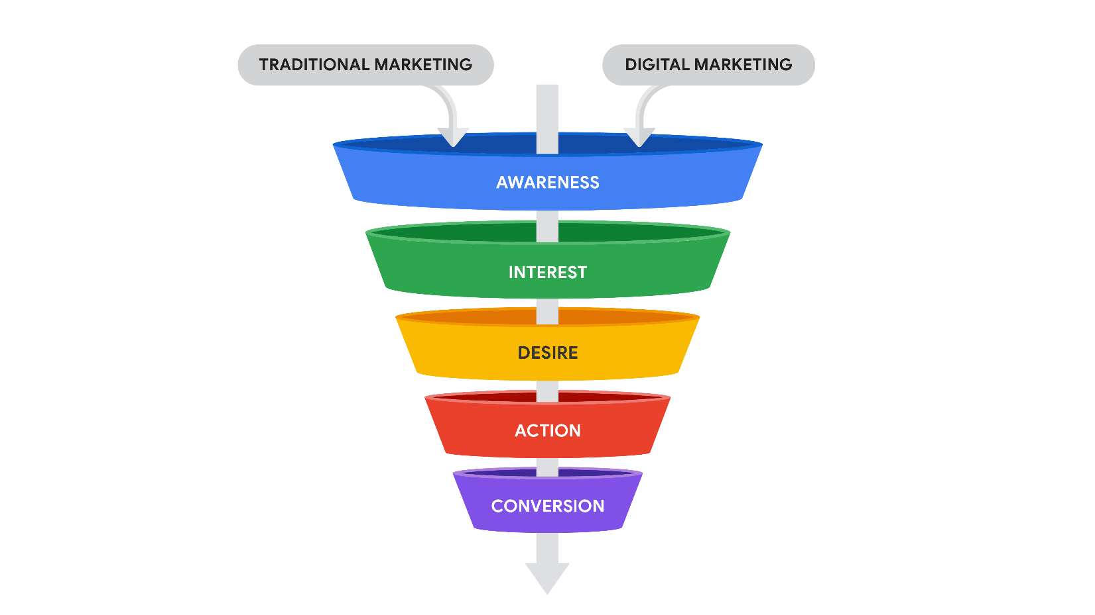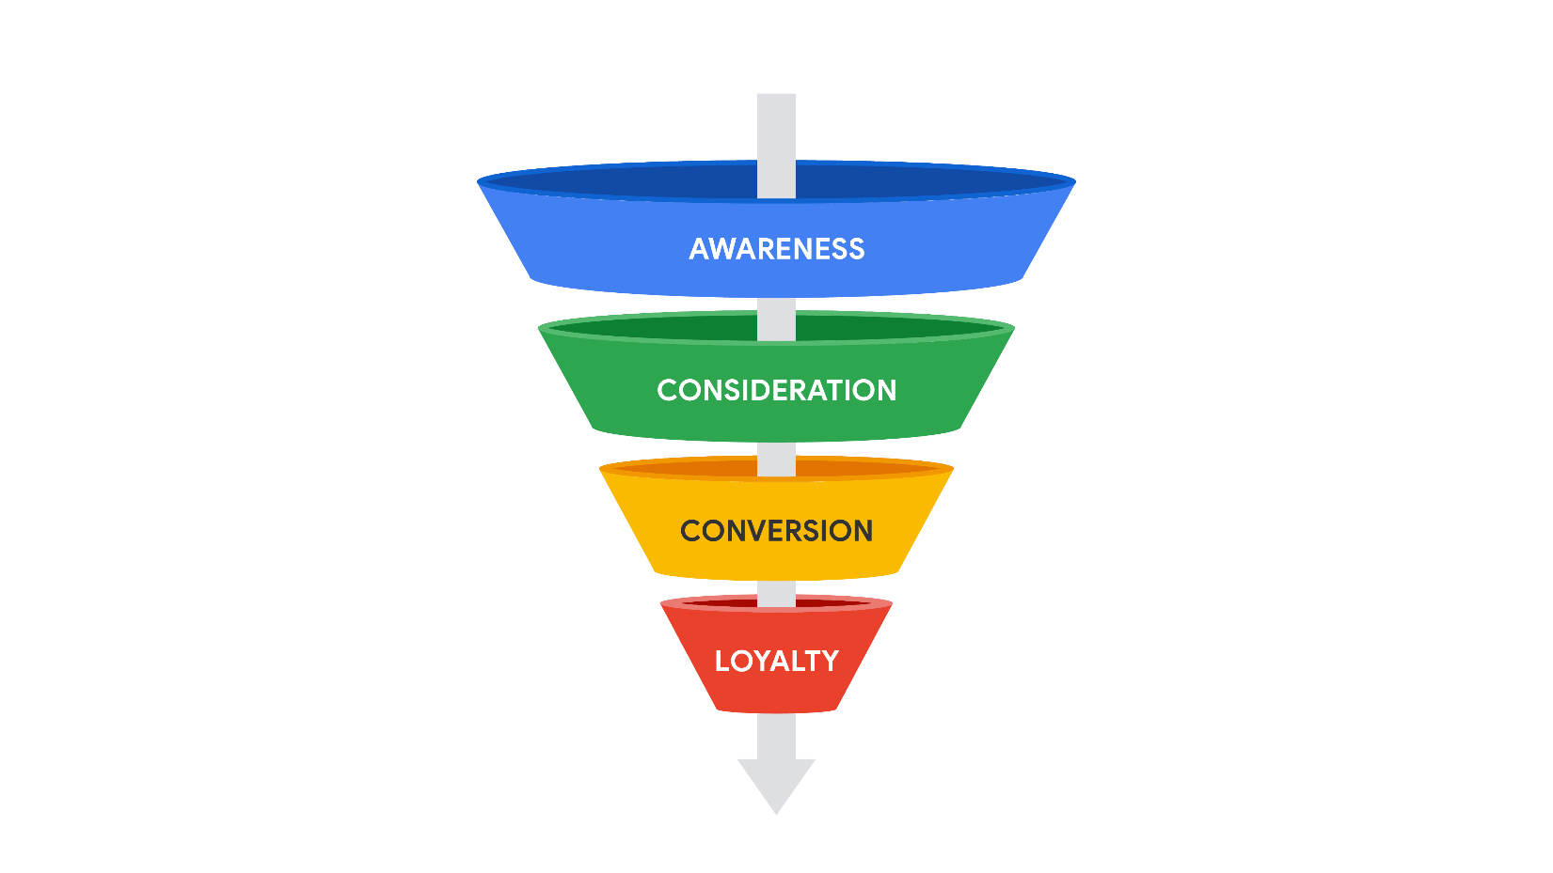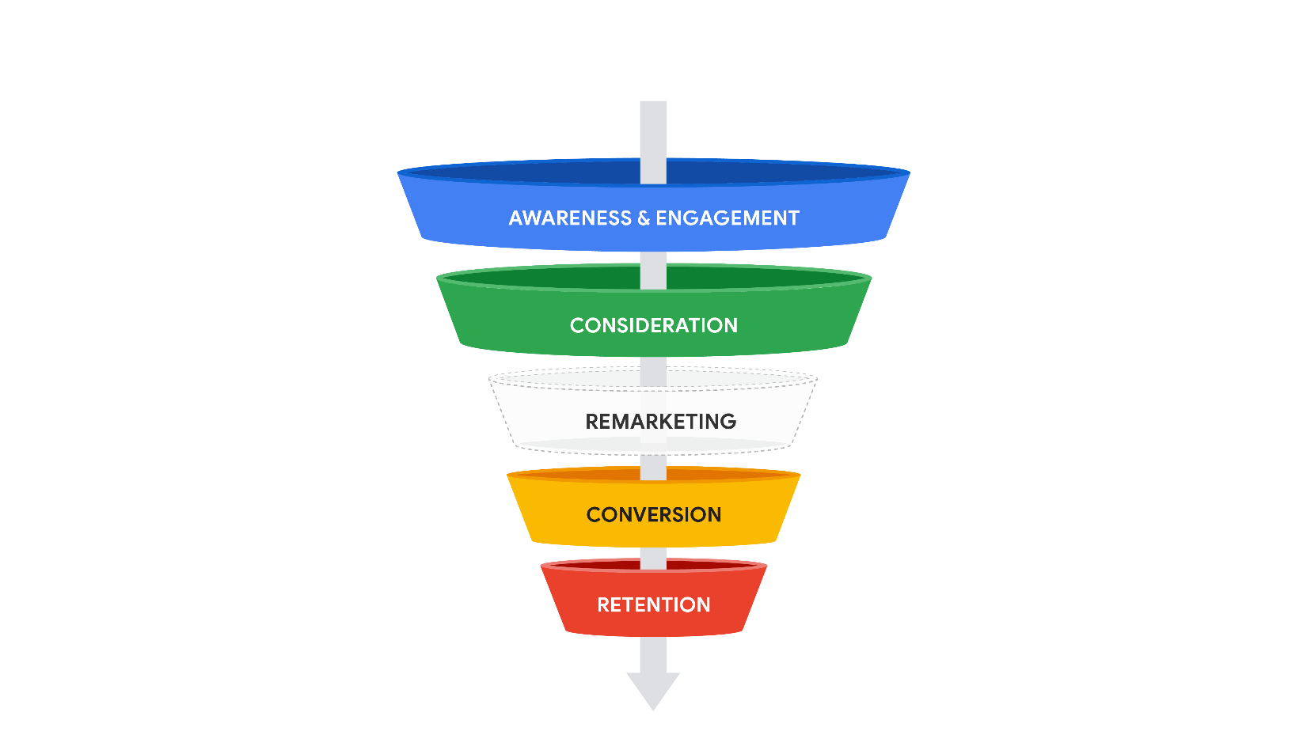Funnel with Awareness and Engagement, Consideration, Remarketing, Conversion, and Retention as downward-progressing stages of the funnel.

Desirable outcomes for a digital marketing funnel, like the one shown in the graphic, might be:

* **Awareness and engagement (ToFU):** The customer has a general awareness of your brand, product, or service, and engages in online activity to learn more.
* **Consideration (MoFU):** Your brand, product, or service comes up as a top choice after the customer has engaged.
* **Remarketing (MoFU):** The customer who didn’t convert is re-engaged to consider your brand, product, or service again.
* **Conversion (BoFU):** The customer purchases your brand, product, or service for the first time.
* **Retention (BoFU):** The customer makes regular purchases and a customer relationship is established.

**Other marketing funnel variations**

Today, specific funnels exist for many individual areas of marketing. Examples include an e-commerce marketing funnel, a social media marketing funnel, and even a content marketing funnel.

**E-commerce marketing funnel**

An e-commerce marketing funnel can include the following stages that focus on attracting and retaining customers:

* **Awareness:** Build awareness of your e-commerce business.
* **Consideration:** Build the brand.
* **Differentiation:** Stand out in the business category.
* **Purchase:** Reach shoppers most likely to purchase.
* **Brand readiness:** Increase the potential for shoppers to make return purchases.

**Social media marketing funnel**

A social media marketing funnel can include these stages that turn a customer with brand awareness into a customer who is an advocate:

* **Awareness:** Attract potential customers unaware of your brand, product, or service.
* **Consideration:** Stand out among your competitors so potential customers have a good impression of your brand, product, or service.
* **Action:** Convince potential customers to act and make a purchase.
* **Engagement:** Keep customers engaged after they make a purchase so your brand, product, or service remains top-of-mind and in the spotlight.
* **Advocacy:** Build trust with customers so they recommend your brand, product, or service to others.

**Content marketing funnel**

A content marketing funnel can include these stages to help marketers organize and focus their content:

* **Awareness:** Build web pages, blogs, social media posts, infographics, and podcasts.
* **Evaluation:** Focus on surveys, email, webinars, and educational events.
* **Conversion:** Provide customer success stories, webinars, specifications, and demos.

**Key takeaways**

The key takeaways for funnels are:

* There isn’t a single funnel that fits all needs.
* Funnels are created for general sales and marketing needs.
* Funnels are also created for specialized areas of marketing.
* Effective marketing efforts incorporate funnels to optimize desired outcomes.

Finally, as a reminder, although this reading introduced a variety of funnels, the marketing funnel that you will refer to often in this program is the one shown below.

# Case study: How MERSEA structures its marketing funnel

Previously, you learned about the different stages of the marketing funnel. In this case study, you’ll learn the marketing strategies that the Lenexa, Kansas based e-commerce company, [MERSEA](https://www.mersea.com/), uses to attract potential customers, turn them into paying customers, and eventually repeat customers. This process represents MERSEA’s approach to the marketing funnel.

There is no standard approach to building a marketing funnel. The various marketing funnel models often share similar strategies and structures, but vary based on the needs of the business.

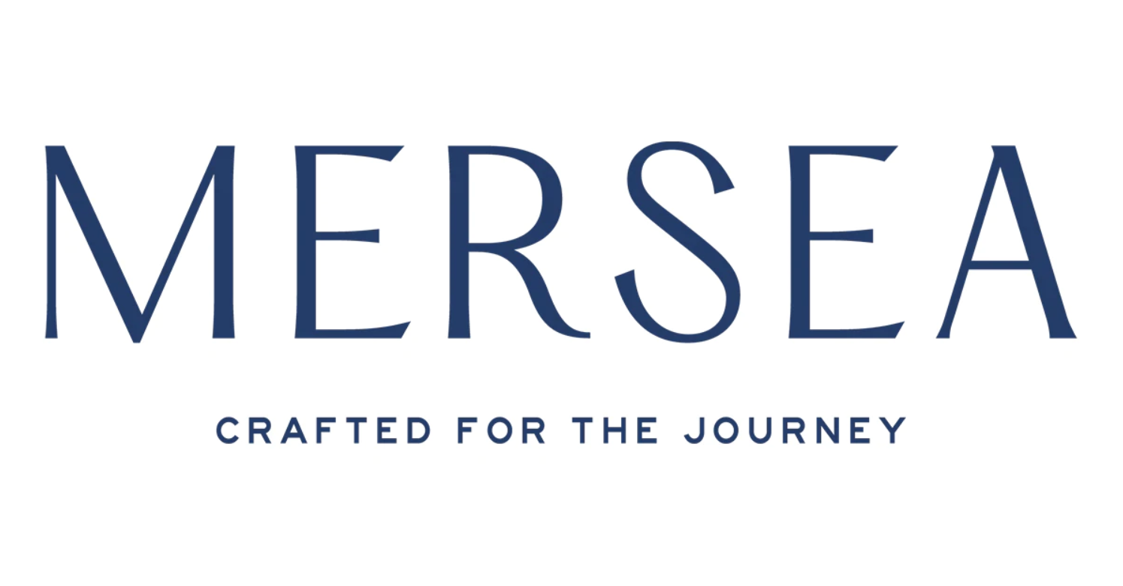

## Company background



In 2013, Lina Dickinson and Melanie Bolin founded [MERSEA](https://www.mersea.com/), a lifestyle brand located in Lenexa, Kansas, offering clothing, accessories, and home fragrances. MERSEA’s products are rooted in the joy of travel and the tranquility of seaside escapes. Initially, Lina and Melanie focused on selling through retail partners, placing MERSEA in over 1,200 stores.

## The challenge

After having a solid presence in retail stores, MERSEA’s founders wanted to increase their e-commerce sales. The challenge MERSEA faced is like many other e-commerce businesses: acquiring new customers online and turning them into repeat customers. This is the core of its marketing funnel.

Imagine the perspective of a business owner. You have a functional online store. But, how can you get potential customers to visit the online store? And, after attracting customers, how can you encourage those customers to revisit the store and become repeat customers?

## The approach

To get the MERSEA brand and product offering in front of its ideal customers, Lina and Melanie used a mix of marketing strategies such as online paid advertising, email marketing, social media marketing, and text messaging.

It’s important to note that MERSEA is not implementing all these strategies with its own employees. They hired an outside marketing company to assist with Google Ads. Working with a marketing company outside of the business allows the founders and its employees to focus on what they’re best at, creating outstanding products.

For busy business owners, it may be beneficial to hire outside of the company to complete tasks, particularly for marketing strategies that require more technical skills. For example, Google Ads requires a knowledge of its platform and how to interpret its metrics.

Organized by marketing funnel stages, here are some marketing strategies MERSEA uses:

### ****Awareness****

For the awareness stage, MERSEA uses online ads including Google Ads and Facebook Ads.

There are several types of Google Ads MERSEA uses. For example, the company uses Search ads for brand name and product searches. It also uses Shopping ads for specific types of products, such as “kimono sweater.” For the Facebook Ads, MERSEA advertises to potential customers from lifestyle-based targeting.

Both of these ads help get the MERSEA brand and products in front of those searching and interested in their type of products.



### ****Consideration****

During the consideration marketing funnel stage, MERSEA continues to apply online advertising, and also uses social media marketing and email marketing.

For online advertising, a marketing strategy MERSEA uses is delivering ads to people who previously visited their website. This is called remarketing. After the customer visits the website, they then receive ads specifically for the products they viewed. This type of advertising is in the consideration stage because the remarketing ads build interest in the potential customer.

For social media marketing and email marketing, MERSEA tells stories about products and introduces potential customers to the brand.

### ****Conversion****

MERSEA is continually working to improve the conversion stage of its marketing funnel. One strategy it uses is following up with customers who have abandoned their carts. An abandoned cart is when a customer adds an item to their cart in an online store but does not make a purchase. If the customer enters their email during the checkout process, but doesn’t make a purchase, MERSEA automatically sends follow up emails reminding the customer about the product in their cart. This follow-up leads to an increase in the conversion rate.

### ****Loyalty****

During the loyalty stage, MERSEA turns its paying customers into repeat customers.

After making a purchase, the customer receives emails about additional and newly released products they may be interested in. These emails are typically sent twice a week: one during the week and another during the weekend.

In addition, one unique strategy MERSEA uses to build loyalty is through text messaging. It has success with sending text messages for order delivery confirmation and updates. When done well, this texting strategy creates a more personal relationship with customers.

## The results

While MERSEA’s success starts with its quality and fashionable products, its well-functioning marketing funnel approach contributes to its success. Within two years of focusing on e-commerce and building an online marketing funnel, MERSEA increased its online sales from 10% to 45%.

Additionally, because of the satisfied customers and the well-developed loyalty stage of its marketing funnel, around 50% of MERSEA’s customers are returning customers.

## Conclusion

There is no one correct way to structure a marketing funnel. A key to a successful funnel is trying and testing new ideas. MERSEA has been successful with its online marketing efforts because it didn’t simply set up an e-commerce store. MERSEA built a marketing funnel to complement it.

A well-made product is important, but a well-rounded marketing approach helps sell the product. A mix of the right marketing strategies drives customers through the funnel. The customers go from unaware of the brand to interested to first-time customers to repeat customers.

Mark as completed

Like

Dislike

Report an issue

The future of e-commerce

Since the web first ushered in a new era of e-commerce, marketplaces, payment services, and massive scaling of shipping and distribution networks have made e-commerce successful. This reading considers how e-commerce might change over the next decade.

**Future trends for e-commerce**

No one can say for sure which innovations today will be used tomorrow. However, a few e-commerce trends stand out:

* Specialization of smaller retailers
* Immersive customer experiences
* Distribution and delivery innovations

**Specialization of smaller retailers**

Large online marketplaces and retailers will still probably account for most online purchases. Smaller retailers may increasingly become more specialized by offering highly customizable products, niche product categories not offered by the larger retailers, and more personalized service.

**Immersive customer experiences**

Today, many customers still like to go to a physical store because they want to handle or try on an item before they buy it. Virtual and augmented reality can provide immersive experiences online so customers feel like they’ve handled an object or tried on a garment without actually making a trip to the store.

**Virtual reality (VR)** is fully immersive. By putting on a VR headset, users are able to view a simulated physical world with audio-visual feedback. Imagine putting on your headset and going to the virtual dressing room to try on clothing items before buying them. That is an example of a VR experience.

**Augmented reality (AR)** is semi-immersive. Users may not need to enter a simulated physical world. AR adds audio-visual feedback to your existing world. What if you could automatically view sunglasses in your shopping cart overlaid on a virtual image of yourself on your phone? What if it saved items from any e-commerce store so you could “try them on” again? This would be an AR solution to shopping at different stores in person.

**Chatbots** are computer programs designed to simulate conversation with human users. They can ask you if everything is fine and if you need help. This would be an online version of a sales associate asking you the same questions in a physical store. Artificial intelligence (AI) and machine learning by chatbots using data from actual conversations may improve the overall experience for shoppers.

**Distribution and delivery innovations**

You might have heard or read about the possibility of drones or self-driving vehicles making the last-mile trip between a warehouse and a residential home or office. These methods of distribution and delivery may be commonplace in the next ten years.

**Key takeaway**

No matter which technologies end up being adopted over the next ten years, e-commerce will continue to grow, and our daily lives and habits will change, too.

Mark as completed

Like

Dislike

Report an issue

# Glossary terms from week 2

## ****Terms and definitions from Course 1, Week 2****

**Awareness stage:** The first stage of the marketing funnel, when a potential customer first becomes aware of the product or service

**Consideration stage:** The second stage of the marketing funnel, when a potential customer's interest builds for a product or service

**Conversion:** The completion of an activity that contributes to the success of a business

**Conversion rate:** The percentage of users or website visitors who completed a desired action, such as clicking on a link in an email or purchasing a product

**Conversion stage:** The third stage of the marketing funnel, when marketers capitalize on the interest people have already shown

**Customer journey:** The path customers take from learning about a product, to getting questions answered, to making a purchase

**Customer journey map:** A visualization of the touchpoints a typical customer encounters along their purchase journey

**Frequency:** How many times an individual encounters an ad

**Impressions:** The total number of times an ad appears on people’s screens

**Inclusive marketing:** The practice of improving representation and belonging within the marketing and advertising materials that an organization creates

**Lead:** A potential customer who has interacted with a brand and shared personal information, like an email address

**Local search:** A search query that generates local-based search results

**Local SEO:** Optimizing content so that it displays in Google's local search algorithms

**Loyalty stage:** The fourth stage of the marketing funnel, when customers become repeat customers and brand advocates

**Marketing funnel:** A visual representation of the process through which people go from learning about a brand to becoming loyal customers

**Omnichannel:** The integration or synchronization of content on multiple channels

**Pain points:** Problems customers want to solve

**Reach:** The total number of unique individuals who encounter an ad across their different

devices

**Target audience:** The group of people most likely to purchase a company's products; often defined as the combination of customer personas

**Touchpoint:** Any interaction a customer has with a brand during their purchase journey

## ****Terms and their definitions from previous module(s)****

## ****A****

**Agency:** An outside partner that fulfills a company’s digital marketing and advertising needs

## ****B****

**Business-to-business (B2B):** Refers to when businesses sell products or services to other businesses (when businesses purchase from each other)

**Business-to-consumer (B2C):** Refers to when businesses sell products or services to consumers (when consumers purchase from businesses)

## C

**Consumer-to-business (C2B):** Refers to when individuals (consumers) sell products or services to businesses (when businesses purchase from consumers)

**Consumer-to-consumer (C2C):** Refers to when individuals (consumers) sell products or services to other consumers (when consumers purchase from each other)

## ****D****

**Digital channel:** Any communication method or platform a business can use to reach their target audience online

**Digital marketing:** The practice of reaching consumers online through digital channels with the aim of turning them into customers

## ****E****

**E-commerce:** The buying and selling of goods or services using the internet

**Engagement marketing:** (refer to **experiential marketing**)

**Experiential marketing:** The process of encouraging consumers to not only purchase a brand or product, but to experience it

## I

**Influencer marketing:** The process of enlisting influential people to endorse or mention a brand or product to their followers on social media

**In-house:** Within a single company

## S

**Social media marketing:** The process of creating content for different social media platforms to drive engagement and promote a business or product

## T

**Transferable skills:** Skills from other areas that can help someone progress a career in marketing